**1.2.1** summary of the data and the questions that I want to explore:

I took the Kaggle data from a website called cardekho that has the details of used cars such as the kms driven, model, year, fuel type, mileage owner type etc., to name a few. Based on this data set, the questions that I want to explore with the data set are:

1.In which year, the cars were bought more.

2.and what type of cars were bought more that year.

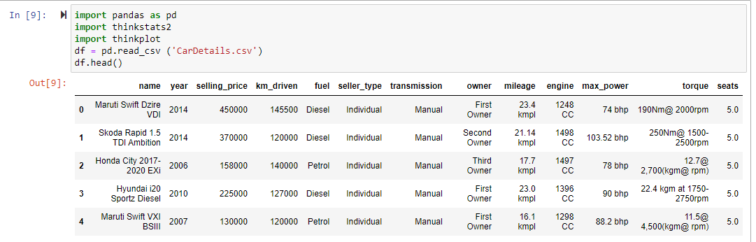

**1.2.2** A Bar chart to show the fuel type and their frequency

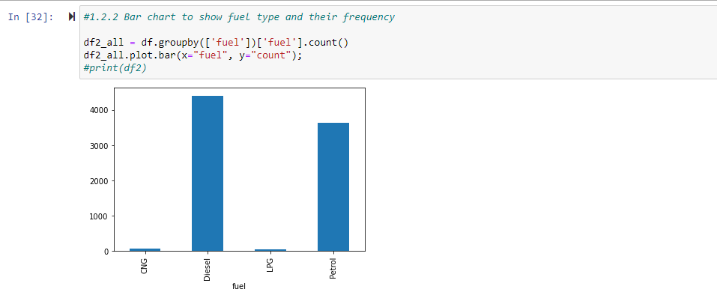

**1.2.3** Box plot on the year.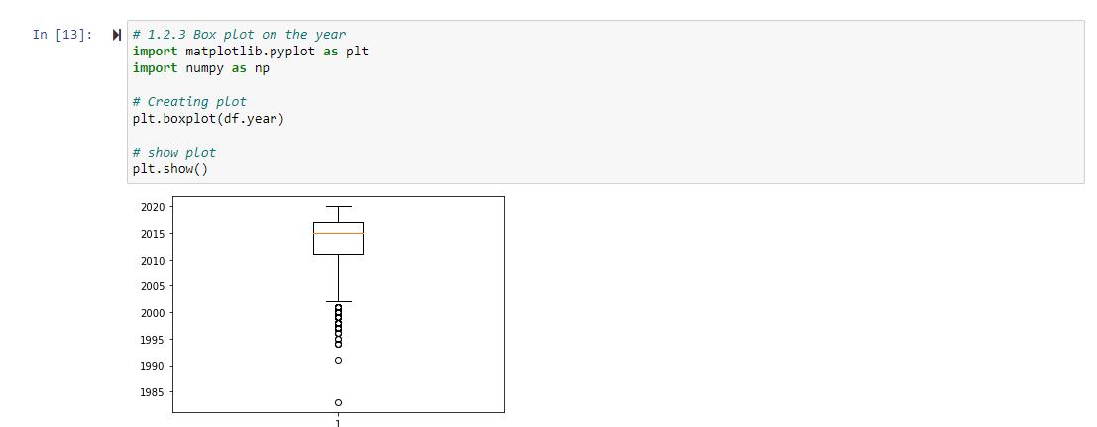

**1.2.4** Bivariate plot between the year and selling price. As the vales in the Y Axis are the selling price that involves big numbers, I used log option to plot it.

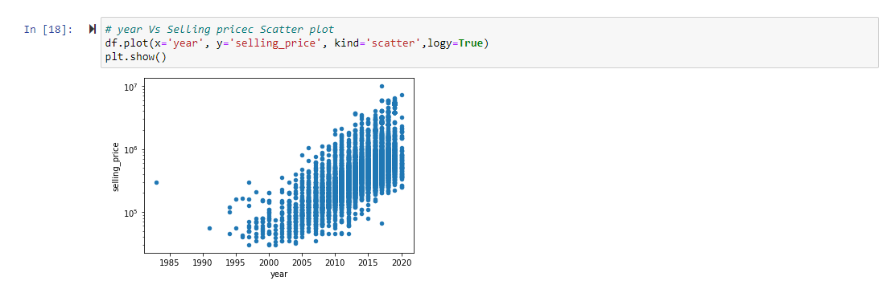

**1.2.5** To answer my first question, which year the cars were bought more, I plotted a histogram that will help us to identify the year. Based on the year, it seems that the cars were bought more in the year 2017.

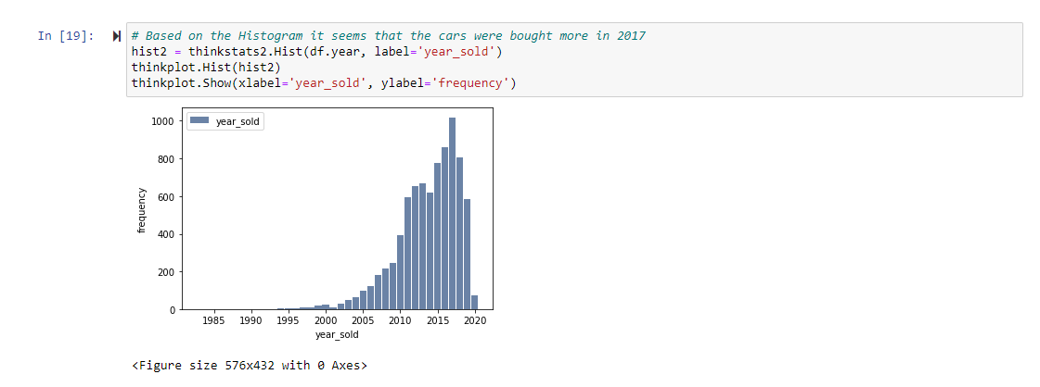

Also, to answer the second question, what type of cars were bought more that year. I plotted a bar chart after filtering the data for the year 2017 for the fuel type and the counts. Based on the bar chart, it seems that the Diesel cars were bought more in the year 2017.

